LUCIA: Investor & Press Overview

PROJECT LUCIA, Inc. | Delaware, USA Contact: info@wearelucia.co
1. Executive Summary
LUCIA is a private Delaware C Corporation and the world’s first hybrid accounting-software company, designed specifically for content creators. We combine proprietary software and expert accounting services, built and managed in-house by our team of engineers and CPAs, to offer accounting and tax services.
The creator economy is booming, yet traditional accountants and generic financial software aren’t equipped to meet its unique needs. Content creators juggle multiple income streams, tax challenges, and specialized deductions, which existing tools simply can't address. LUCIA is here to change that, with over eight proprietary software tools, including project management and net worth tracking, all built to simplify and optimize creators' financial lives.
LUCIA is on track for rapid growth, projecting a market capitalization of $4 billion USD by 2030, positioning it as one of the fastest-growing hybrid accounting-software companies in North America. For context, Pilot, a startup accounting software targeting startups in North America, reached a valuation of $1.2 billion USD within just four years. LUCIA’s growth is fueled by its exceptional founding team, with expertise spanning accounting, international tax, marketing, sales, and software engineering. The founders’ collective experience includes scaling startups, leading successful exits, and buying and selling multiple businesses globally.
2. The Problem
The Creator Economy is a multi-billion-dollar industry, yet its financial infrastructure remains fundamentally underserved.
- Complex Income Streams: Creators often receive income from 5+ sources (AdSense, sponsorships, affiliate links, merch, platform payouts, etc.). Traditional accounting tools are not designed to consolidate or interpret this complexity.
- Lack of Specialized Knowledge: Generic software and traditional accountants rarely understand digital-platform revenue models, creator-specific deductions (home studios, equipment, production expenses), or U.S. international tax reporting requirements.
- High Financial Risk: Disorganized finances lead to large tax-liability exposure, missed deductions, unreliable income records, and difficulty securing business financing - all of which limit a creator’s ability to grow.
3. Our Solution
LUCIA’s software tools benefit two main stakeholders.
A. Internal Staff Efficiency (The Mechanic Analogy)
Most accounting firms still operate manually - like a mechanic (Shop A) who inspects every engine part by hand.
LUCIA functions like Shop B: a mechanic equipped with a proprietary diagnostics system that immediately scans the financial engine and surfaces issues.
As one of the few true software-first accounting companies, we build and use our own tools exclusively. This allows our team to complete work up to 90% faster than traditional accountants while maintaining higher accuracy.
B. Content Creator Benefits
Our tools go far beyond basic tax filing. They help creators:
- Track long-term business and personal financial goals
- Monitor net worth
- Receive actionable, real-time financial insights
This model frees creators from administrative work and enables them to focus their time on what matters most - creating content
Simple Comparison
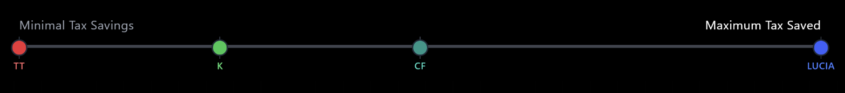
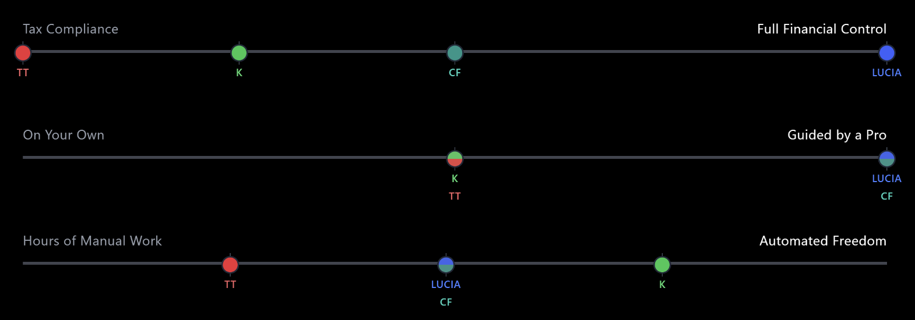
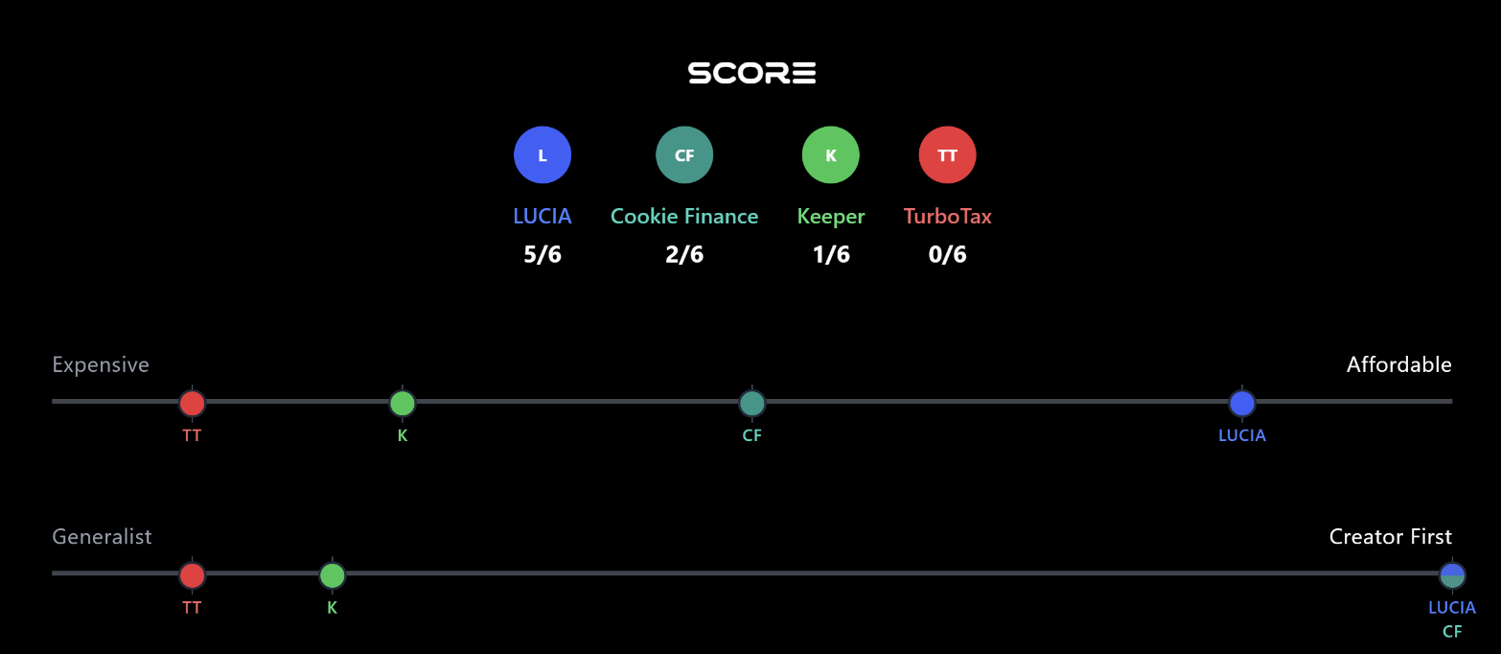
We compared LUCIA to three other companies across six key factors that content creators care about when it comes to accounting services.

Detailed Comparison

We performed a detailed comparison of LUCIA with 3 other competitors using a table format.







4.Founding Team & Advisors
LUCIA was founded by 27-year-old New Zealander Priyesh Ramesh (CEO, accounting background) and Henk Willcock (CTO, software engineering background).
Priyesh Ramesh

Priyesh has a broad accounting background, having worked with businesses across multiple countries and reaching Senior Manager level by age 26. During this time, he worked with some of the world’s largest organisations while living in the U.K., Europe, and New Zealand. He has experience across all major areas of accounting -including Audit, Management Accounting, Financial Accounting, and FP&A, which is rare at his age.
While in London and travelling through parts of Europe, he spent time around content creators who consistently shared the same frustration: no accountant truly understood creators, and most accountants felt overly corporate in tone, style, and attitude. Many creators were surprised to learn Priyesh was an accountant at all - his interests and personal style (high-tops, jeans, hockey jerseys) didn’t match the stereotypical corporate image.
An adrenaline-seeker with interests in skateboarding, rock music, hiking, boxing, and MMA, Priyesh shared his view that traditional accountants lacked authenticity and rarely showed genuine interest in the creator’s craft. He saw that creators come from varied industries, yet were often forced into a rigid, one-size-fits-all service model.
Inspired by rebellious, culture-driven brands like Liquid Death and Skullcandy, Priyesh set out to build a company that broke away from the corporate mould - one that is authentic, creator-aligned, and unapologetically tech-driven.
Henk Willcock

Henk has a strong background in software engineering, with most of his career focused on building finance-related systems. Throughout his work, he has observed a recurring issue in the tech sector: while creating software is relatively easy, creating high-quality, durable software is far more challenging.
He was accepted into and completed the Fintech Startup Accelerator run by Creative HQ in New Zealand. During this time, he built the first and only financial-statement automation platform for the New Zealand education sector. Accountants typically spend 15-40 hours preparing financial statements for a single school; his software reduces this to as little as two hours. This innovation addressed a widely recognised issue: fewer than half of New Zealand schools meet the statutory 31 May deadline for preparing, auditing, and signing their financial statements - a number that has been declining each year. Henk’s software significantly increases the likelihood of schools meeting this requirement.
Henk’s technical expertise positions LUCIA to consistently deliver high-quality software. Outside of work, he has a laid-back personality, enjoys sailing and hiking, and having navigated contractor taxes himself, understands the gap in accounting support for independent workers.

In late 2025, LUCIA added three U.S.-based co-founders: Dianne Liu, Ari Tretin, and Matthew Moosavian. Their addition created a founding team with a uniquely complementary mix of skills across accounting, marketing, sales, and software engineering.
Most accounting-software startups are typically founded by either engineers or accountants - rarely both, and even more rarely with dedicated sales and marketing expertise. LUCIA’s structure gives it an unusually strong foundation compared with the typical industry profile.
Matthew Moosavian

Matt is a former Division I athlete turned operator, investor, and growth strategist. He brings over a decade of experience building and scaling high-growth businesses at the intersection of fitness, human performance, and technology. Matt is the founder of FLEX, the “WeWork of fitness,” and MXT, a performance training brand. He has worked closely with dozens of early-stage companies across health tech, fitness tech, and performance optimization, offering capital, strategy, and hands-on operational support.
Before joining this platform, Matt served as an early growth hire at Vital.io, where he led go-to-market and sales operations. He played a key role in scaling SQL volume by 400 percent by building and optimizing full-stack GTM systems, leveraging automation, and applying efficient growth strategies.
As an elite-level athlete, Matt has qualified for the Boston Marathon with a 2:39 time, is a three-time HYROX World Championship qualifier, and is a sub-10:00 Ironman finisher. He has built his personal social media presence to more than 15,000 followers, managing and securing his own brand partnerships and sponsorship contracts with top-tier performance brands. He brings a unique lens to venture and business building through firsthand experience using the same tools, services, and systems that help high performers live, work, and lead better.
Dianne Liu

She is a passionate Marketing and Growth Executive with a strong background in driving digital transformations and scaling startups toward profitable outcomes. Her journey has been driven by a passion for unlocking growth through strategic customer acquisition, innovative product marketing, and meticulous funnel optimization. She is deeply committed to data-driven results, leveraging analytics and the latest in digital marketing technology to achieve business objectives.
Dianne takes pride in her ability to cultivate high-performing teams and build revenue-focused marketing engines from scratch. Her approach is hands-on; she is not just at the helm guiding her team but also in the trenches, ready to accelerate growth efforts whenever needed.

Her expertise spans all facets of marketing management - from precise budgeting and lead generation to crafting digital campaign strategies. She has implemented marketing plans that resonate across channels, featuring captivating corporate events, targeted social media execution, and streamlined project management.
As a cross-functional leader, she brings a blend of resourcefulness, curiosity, and an unwavering “can-do” attitude to all her professional endeavours.

Ari Tretin

People, Product, Process.
Ari thrives at the intersection of creativity, strategy, and technology. He brings expertise in CRM implementation, social content production, platform development, storytelling, long- and short-form video, strategic planning, and consulting, leading initiatives that connect brands with their audiences in meaningful ways.
He has led customer-driven marketing campaigns for global brands across luxury automotive, sports, retail, luxury design, and footwear, translating complex business objectives into compelling stories and experiences that resonate with real audiences.
Ari is equally passionate about the processes and systems that enable teams to succeed - designing efficient workflows, scaling content production, and ensuring that every project reflects both creative vision and strategic intent. At his core, he is driven by helping people and brands bring bold ideas to life while keeping execution focused, creative, and results oriented.
LUCIA currently has four advisors.

Vasiliki Papadopoulos
Vasie has helped Fortune 500 companies, startups, and mission-driven organizations navigate high-stakes moments and unlock long-term growth - from crisis and issues management to C-suite counsel, strategic campaigns, and media training. Whether building consumer trust, shaping public opinion, or preparing leaders to shine in the spotlight, she brings a rare blend of strategic insight, creativity, and calm execution. Vasie has experience both in the public and private sectors developing strategic communication plans, data-driven business strategies and campaigns and creating unique company initiatives working at the Government of Canada, Metrolinx, the Financial Services Commission of Ontario and Philip Morris International. She has lived and worked in Canada, Switzerland, and the US, giving her a global view.
She has an undergraduate degree in political science from the University of Ottawa, a master’s degree in philosophy from the University of Edinburgh, Scotland, and an executive MBA from Ivey School of Business.
She also designs shoes and is an accomplished travel photographer.
In 2020, she was named one of Canada’s Top 100 Most Powerful Women through the Women’s Executive Network.

Nick Abrams
Nick is a licensed CPA who spent over three years at Ernst & Young (EY) before founding and operating his own CPA firm in Los Angeles. His practice focuses on small-business tax, nonprofit filings, individual tax preparation, and tax planning.
Nick believes the creator economy is heading toward a severe capacity crisis. Approximately 75% of all CPAs are expected to retire within the next 15 years, a trend already recognized across the industry. With fewer qualified accountants entering the profession -and increasing regulatory complexity - content creators will face:

- Longer wait times to secure a CPA
- Higher service fees
- Less access to practitioners who understand digital-first business models
- Greater risk of filing errors, missed deductions, or IRS penalties
This shortage compounds an already significant issue: very few accountants truly specialize in creator-economy income streams. As supply drops and complexity rises, creators will be left with even fewer options for accurate, timely, and relevant financial support.
Travis Ayers

Travis has produced various films. These include: Adjust Your Tracking (2013), CYST (2022), Miracle Valley (2022), INFRARED (2022), The Christmas Tapes (2023), Forbidden Sky (2025), and The HEM (2025).
Through his work in film and media, Tavis has firsthand experience with the financial challenges creators face. He has encountered accountants and financial tools that are ill-suited to creative professionals, struggling with complex income streams, inconsistent reporting, and lack of industry-specific guidance. This perspective informs LUCIA’s mission: to provide specialized accounting and software solutions that truly understand creators’ needs, helping them manage finances efficiently while focusing on their craft.

Cassie Noyes

Cassie is passionate about helping creators grow through brand strategy, messaging, and storytelling - building authentic, human connections between creators and their audiences. She has led audience growth and engagement for more than 100 of the largest online food and lifestyle creators.
She has a proven track record of driving audience growth, digital transformation, and multi-channel marketing for media, lifestyle, and creator-driven brands. She has built and led high-performing teams, scaled products from concept to execution, and delivered measurable revenue and engagement results.
Her expertise spans data-driven strategy, brand extension, audience development, and executive leadership - consistently turning creative vision into sustained, scalable growth.
5. Future Vision
LUCIA’s vision involves:
- Global Expansion: Targeted entry into key markets across Asia, Europe, and the Middle East. LUCIA is projecting a market capitalization of approximately USD $4 billion by 2030, based on planned expansion and product growth.
- Horizontal Expansion into Sports Entertainment: Development of an MMA-influencer league. Matthew’s Division I athletics background and Priyesh’s long-standing interest in combat sports (wrestling, boxing & MMA) provide direct insight into the fast-growing crossover combat space, following the momentum created by platforms such as Misfits Boxing.
6. Investor & Press Next Steps
For Investors: We are not actively raising capital currently, but we remain open to investor conversations. Please contact us to arrange a confidential discussion.
For Press: We welcome media inquiries and can provide expert commentary on creator-economy financial trends, tax compliance, and the application of AI in specialized business services. A full media kit is available upon request.

